EX NO 1
Data Preprocessing in Given DataSet

Aim
To preprocess a dataset by checking and handling missing values and normalizing numerical features using the StandardScaler class from the Scikit-learn library.
Algorithm
- Import the Pandas library and StandardScaler from sklearn.preprocessing.
- Load the dataset from the CSV file data.csv using pd.read_csv().
- Display the first five rows of the original dataset using data.head().
- Check and display the missing values in each column using data.isnull().sum().
- Fill missing numerical values with the mean of their respective columns using data.fillna(data.mean(numeric_only=True), inplace=True).
- Select the numerical columns Hours_Studied, Attendance, Assignments, and Marks.
- Create a StandardScaler object.
- Normalize the selected numerical data using scaler.fit_transform(X).
- Convert the normalized array back into a Pandas DataFrame with the original column names.
- Display the first five rows of the normalized dataset.

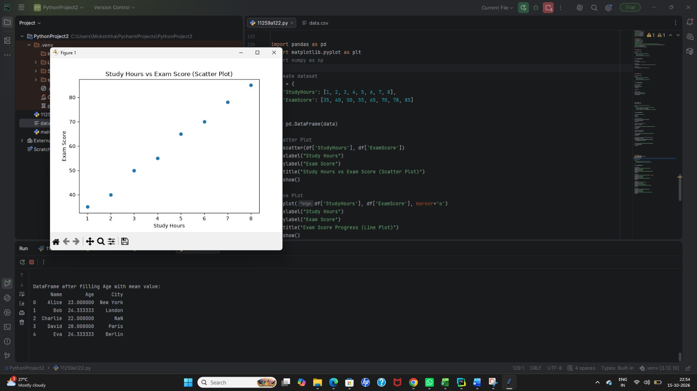

Result
The dataset was successfully loaded and inspected for missing values. Missing numerical values were replaced with their respective column means, and the selected numerical features were normalized using StandardScaler.
After normalization, each selected feature has a mean approximately equal to 0 and a standard deviation approximately equal to 1 (using the population standard deviation).

